Please read this brief carefully before completing the role

JOB: RETAILER NAME Check, fix & purchase call on XXX range £10.50/call + up to £XXX Product Purchase (complete XXX)
RETAILER: Insert retailer name
PRODUCTS: Insert name of brand / products to check
COMPLETION: Insert date to be completed by or dates from / to to complete
PAY: £10.50 (min we’d suggest)
EXPENSES: £XXX for the purchase of XXX.
If you anticipate a high outlay for expenses we would suggest you put what the likely purchase value will be

Sales data can be tracked at product and store level, all expenses are independently audited against visits made.

OVERVIEW / BACKGROUND TO THE CALL
INSERT HERE details around what the purpose of the visit is to give the worker some background.
For example…
We need are rolling out new packaging / bottles / labels into store and would like to clear out all old stock. We need you to pop into store, check the stock that is on shelf and purchase ALL stock of XXX as per the images below. We anticipate that there could be up to XX units per store – please ensure you check stock carefully and only purchase what’s required. We expect them to be priced at £XX
There is no issue with the stock so it is safe for consumption – please share with family / friends / donate to a food bank. This product not for resale.
This needs to be done as a shopper so please be discrete when taking photos.

WHAT DOES A GOOD JOB LOOK LIKE:
INSERT HERE what success looks like – keep it brief & clear what your expectations are
For example…..
All stock of product X purchased – you may need to ask for any stock in the warehouse.
All NEW stock of product X faced up on shelf so it looks good for other shoppers.
Good quality before & after photos to clearly show the product range and price
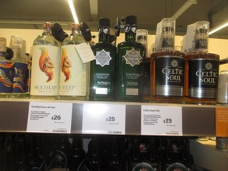

LOCATION IN-STORE: XXXXXX Fixture

PRODUCTS TO CHECK:
INSERT table here with product name / pack size / weight / expected retail price

INSERT IMAGE OF FIXTURE IN-STORE, ideally of what a good job looks like so workers can easily identify the fixture where they will find the product and see what they need to achieve

Old Bottle: PURCHASE ALL OF THESE BOTTLES ON SHELF
New Bottle: DO NOT PURCHASE THESE BOTTLES
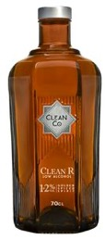
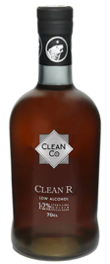
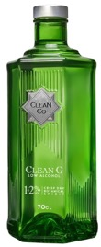
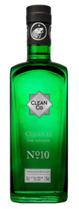
INSERT IMAGE OF PRODUCT TO CHECK / PURCHASE
If quality issue – show what it is
If BB4 date or batch code – show image of it
Make it easy for workers to differentiate what they should / should not buy
If Old / New packaging – show both options & make it clear what they should / should not buy

REQUIREMENTS OF THE ROLE:
- Go into the allocated store & head to the XXXX fixture and locate XXXX (if it’s an unusual location then please describe where to find it)
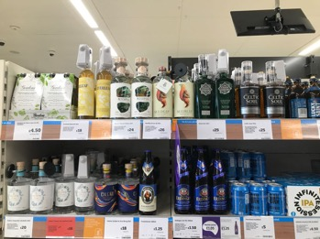
- BEFORE YOU REMOVE ANY STOCK - Take a close-up photo showing the stock onshelf & price ticket.
- Then take a wider photo showing the surrounding fixture and products.
- You will need to count how many OLD units of XXX and XXX are on shelf.
- You will also need to count how many NEW of XXX and XXX units are on shelf.
- Remove ALL OLD STYLE XXX and take an AFTER PHOTO showing any remaining stock on shelf, or an empty shelf if you have bought all the stock.
- Take a wide angle photo of the XXX Aisle
- Ensure ALL OLD STYLE XXXX are removed from the shelf AND purchased.
- If you can’t find XXX or XXXX on shelf please ask a colleague in-store to see if they can find it for you - Note who you spoke to & what they said
- Please take photos of stock purchased
- Upload your receipt to the expenses section, and the report section and complete / submit your timesheet. Your receipt MUST SHOW THE DATE & TIME OF PURCHASE + STORE NAME / NUMBER so you may need to upload back & front

REPORTING QUESTIONS
- What date did you visit the store?
- What time did you visit the store?
- Was XXXX available?
- Did XXX have a price ticket?
- What was the price?
- Was XXXX available?
- Did XXX have a price ticket?
- What was the price?
- Close up photo of product on shelf on ENTRY
- Wider photo of XXX fixture / aisle showing product on ENTRY (THIS IS MANDATORY WHETHER XXX IS PRESENT OR NOT)
- If either XXX product was not available who did you speak to in-store?
- What did they say? Can they look in the warehouse? Can they find the stock for you? Please note full details
- How many units of OLD STYLE XXX were on fixture?
- How many units of NEW STYLE XXX were on fixture?
- How many units of OLD STYLE XXX were on fixture?
- How many units of NEW STYLE XXX were on fixture?
- Photo of XXX range on fixture on exit (tidied up & looking great!) or gap if not available
- Wider photo of XXXX aisle showing product on EXIT
- Photograph of XXXX products
- Photograph of XXXX products
- Any other comments or feedback?

Once we have verified this, you will be paid on the next payroll according to your preferences.
Thanks for being a part of the revolution! Don't forget to tell your friends/family about redwigwam & BRAND NAME

Many thanks,
The INSERT BRAND NAME Team

PLEASE DELETE THIS SECTION BEFORE SAVING YOUR FILE AS A PDF (remember to reduce the images as max file size is 5MB)
To get your job loaded & live please log into your account https://hirer.redwigwam.com/login/
On your dashboard go to JOBS – ADD A JOB, Select Sector – RETAIL, Select Job Type – MYSTERY SHOPPER,
Select template job - Retail - product quality / BB4 date / old stock - check & fix on XXX range £10.50 (complete XXX)
You will then need to update the job according to your requirement and also ensure you amend the products / pricing in the reporting section too from XXXXs / ABC.
If you need help then please pop onto live chat or email catherine@redwigwam.com

